PLEASE NOTE THAT SOME SLIGHT CHANGES MAY OCCUR
Award ceremony will be held in Yerevan on May 31st, 2018
in “IBIS Yerevan Centre” hotel
(5/1 Northern Avenue, Yerevan, Armenia).

The Seventh International Young Women’s Peace Award Ceremony
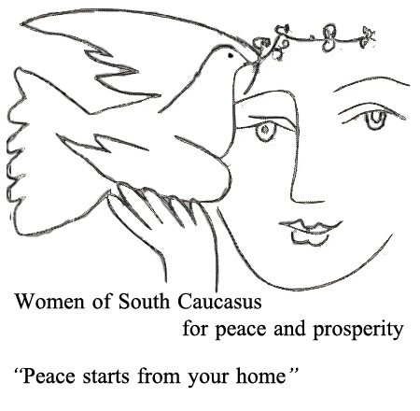

Thursday, May 31 - 20.00 -22.30

20.00- 21.00 | - WOMEN’S WAY OF BUILDING PEACE AND TRANSFORMING THE WORLD -
 | Anahit Bayandur¹, Zabel Yesayan² and Irena Sandler³
 | Annual ceremony of “ International Young women’s peace award” dedicated to work of Anahit Bayandur, Olof Palme Peace Laureate. | Introductory remarks by Gulnara Shahinian, chair “Democracy Today”
 | Anahit Bayandur’s legacy - publicist, translator peace activist and diplomat | H.E. Hrant Bagratian, former Prime Minister of Armenia, Depute to National Assembly of Armenia
 | Zabel Yesayan – outstanding Armenian woman, writer, political figure | H.E. Mr. Jonathan Lacôte - Ambassador Extraordinary and Plenipotentiary of French Republic in Armenia.  Judith Sarian⁴, researcher and lecturer on Zabel Yesayan.  Demonstration of film “Zabel Yesayan Women of Letters Honored in Paris”.
 | Irena Sandler – humanist, social activist, heroine | H.E. Mr. Paweł Cieplak- Ambassador Extraordinary and Plenipotentiary of Republic of Poland in Republic of Armenia  Demonstration of film “Courageous Heart of Irena Sandler”  Sharing memories on Irena Sandler Skype from Poland.
21.00-22.30 | “International Young women’s peace award ceremony”
 | Opening of photo exhibition of photographer Adriane Ohanessian⁵ presenting her work in Sudan
 | Reception
 | The program will be conducted by famous singer and educator Eka Horistka⁶ and Musical group “Tsirani⁷” ensemble.

- Anahit Bayandur translator, public figure, diplomat famous peace activist. She has translated into Russian works of contemporary Armenian writers . It is due to her that those authors have become popular abroad. She has been member of Armenian Parliament and chaired commission on Armenia –Russian relations. It should be noted that in 1992 Anahit Bayandur won the prestigious Olof Palme award for peace for her outstanding work for peace in the region. She is author of many publications .
- Zabel Yesayan (was born in Constantinople in 1878, one of the first women from the Ottoman Empire to pursue higher education overseas in Sorbonne. In 1908 after the reinstatement of the Constitution, returning to she reached out to others including Muslims in order to start an Ottoman Women's Peace Organization. Her attempts were thwarted by the massacres of Adana in 1909. She witnessed the aftermath and wrote about it. In her testimonial account, In the Ruins, published in 1911 and one of the most powerful books written about the Armenian experience during the first half of the twentieth century. In her Preface, Yesayan appealed for understanding from all members of the Ottoman State. In the Ruins was widely read and reached the attention of the Turkish authorities. The only woman on the list of Armenian intellectuals who were targeted for arrest on April 24, 1915, she escaped first to Bulgaria and then to Baku where she recorded eyewitness accounts of the Armenian Genocide. She submitted reports to the 1919 Paris Peace delegations about the enslavement of Armenian women and children during the Genocide and its aftermath. She returned to Cilicia in 1920 to provide relief for the orphans and aid with evacuation. Eventually in 1933 she repatriated to Soviet Armenia, and it was there that she wrote The Gardens of Silihdar, her lyrical memoir about growing up in Constantinople. Charged with being an enemy of the people for her support of Armenian writers and other unsubstantiated accusations, she was arrested by Stalin's henchmen in 1937 and remained in prison for 6 years, dying under mysterious circumstances.
- Irena Sendler (Irena Sendlerowa at birth) - a women who would bridle at being called a heroine, so let us call her a social activist. She saved 2,500 Jewish children. Not by herself, as she always emphasized. During the war and the time of the occupation, she dreamt of having dry shoes. Her interests were politics, history, and people. She was born on 15th February, 1910 in Warsaw and died there on 12thMay, 2008.
- Judith Saryan - after 37 years in finance, Judith Saryan changed direction and pursued her passion for literature and history. She spearheaded the project to translate the works of Zabel Yesayan, Ottoman Armenian author and political activist, into English. Her goal is to resurrect the legacy of Zabel Yesayan who deserves a prominent place in the literary firmament.
- Adriane Ohanesian - since 2010, has worked as a photojournalist in Africa. She has continued to document the conflict in South Sudan, fighting in Somalia, protests in Burundi, and the war in Darfur, Sudan. Adriane’s ongoing focus has been on the impact that these conflicts have on isolated civilian populations.
- Eka Horistka - famous singer and educator, co-founder of "Artissimo" NGO and Beacons musical group.
- “Tsirani” ensemble - The “Tsirani” ensemble was founded in 2012. The band was initially an instrumental quintet – duduk, shvi, tar, oud, dhol /double headed drum/, where duduk was the main instrument. In 2014 singers joined the band.

